School of Sociology

Plagiarism Protocol

Based on Plagiarism Procedure document agreed by School TL Committee in Feb 2020 and revised in Oct 2020 to align with new University Plagiarism Policy document.

School Plagiarism Advisor: Director of Teaching and Learning
School Plagiarism Committee: Director of Teaching and Learning (chair), two additional members of the School Teaching and Learning Committee

Procedure for Dealing with Plagiarism at the School of Sociology

- If a student is suspected of plagiarism, the Module Coordinator (MC) reaches out to the student in the first instance if clarifications are needed.
- After that the MC initiates the plagiarism procedure if the grounds for suspected plagiarism persist, outlines the case to the student and consults with the School Plagiarism Advisor (SPA). Unless otherwise agreed upon by the School, the SPA is the Director of Teaching and Learning.
- If plagiarism is alleged, the MC refers the case to the SPA with a short report outlining the grounds of suspicion, a copy of the piece of work and any supporting evidence.
- The student is informed by the SPA through the student’s UCD email address that
  - an assessment is under scrutiny as an alleged instance of plagiarism and that the case is now being investigated by the School Plagiarism Committee (SPC).
  - The student is also informed by the SPA about sources of support, such as those provided by the Student Advisors and/or the Students’ Union.
- The SPA convenes the School Plagiarism Committee (SPC), which consists of the SPA and two other members of the School Teaching and Learning Committee.
- The SPC evaluates the case and decides on whether plagiarism has taken place or not.
- If the SPC decides that no plagiarism has occurred, the assessment component grade stands. No record is made on the Plagiarism Record System.
- If the SPC decides that plagiarism has occurred, the student is invited by the SPA to discuss the allegation with the SPA and/or make a written statement.
- The SPA looks up the record of the student in the Plagiarism Record System and uses this information together with the UCD adaptation of the AMBeR Plagiarism Tariff (see appendix 1 and 2) and a potential written statement of the student to make a recommendation to the SPC for plagiarism points that the students will be awarded in the Plagiarism Record System. The SPA may request further documentation from the student, i.e. in the case of extenuating or mitigating circumstances.
- The SPC comes to an agreement about the severity of the case and plagiarism points that will be awarded to the student in the Plagiarism Record System based on the recommendation of the SPA and the UCD adaptation of the AMBeR Plagiarism Tariff (see appendix 1 and 2).
- In cases where the new total sum of plagiarism points of a student exceeds 480, the case gets directly referred to UCD Discipline by the SPA with all supporting documentation. When a case gets referred to UCD Discipline, the record of the student in the Plagiarism Record System will be updated by UCD Discipline. Further decisions will be made by UCD Discipline.
- When a case gets not referred to UCD Discipline, the SPC also makes a decision on a specific action based in the student’s plagiarism points and the UCD adaption of the AMBeR Plagiarism Tariff (appendix 3). Such an action can include:
  - Provisional awarding of NM grade, resubmission permitted with late submission grade penalty.
  - Provisional awarding of NM grade, resubmission permitted but grade further capped or reduced.
  - Provisional awarding of NM grade, no opportunity for resubmission.

- The SPA updates the record of the student in the Plagiarism Record System with the newly awarded plagiarism points.
- The SPA issues a verbal or written warning and informs the student of the outcome of the SPC investigation. The SPA also directs the student on how to receive advice about academic integrity.
- The SPA informs the MC of the outcome of the SPC decision and the penalty that may apply.
- The student can appeal an outcome (decision and/or penalty) of the SPC following the University Student Appeal Procedure.

Appendix 1: Guide to AMBeR Plagiarism Tariff

Guide to using the AMBeR Plagiarism Tariff
Context
In order to address the challenges of transparency and consistency in the penalties imposed for student plagiarism in the UK, the AMBeR Plagiarism Reference Tariff was designed as a guide to the application of penalties that may be imposed for student plagiarism in Higher Education. It is widely used in the United Kingdom and to a lesser extent in Ireland.
The tariff is available at https://tinyurl.com/w9qnkb5 and a report on its development is available at https://www.plagiarism.org/paper/plagiarism-reference-tariff.
The tariff is not designed to be used to assist in determining whether a student has plagiarised. The purpose of the tariff is to determine an appropriate penalty, once plagiarism has been established.
UCD
With the introduction of the revised Student Plagiarism Policy in UCD in 2020, it is proposed to use the AMBeR Plagiarism Tariff as a basis for a UCD Tariff to guide relevant staff, e.g., student plagiarism committees, student discipline committees, in making plagiarism penalty decisions.
While the tariff is primarily designed to be used for deciding penalties in cases of plagiarism identified in assessments that are graded, an additional tariff table has been included in the proposed UCD tariff to take account of a) research degree theses, b) PhD Stage Transfer Assessments, or c) final PhD dissertation submission or d) pass/fail assessments, because they do not receive a graded outcome.
Notes
The tariff is a guide for penalties and only takes account of aspects directly associated with plagiarism. Some of its weaknesses that have been highlighted in https://www.plagiarismtoday.com/2012/08/06/looking-at-the-AMBeR-benchmark-plagiarism-tariff/ are shown below.
- Collusion: The tariff is not designed to deal with collusion, cases of students working inappropriately together on the same assignment.
- Extenuating Circumstances: The tariff does not take account of extenuating circumstances.
- Long-Term Impact: The tariff does not weigh the long-term impact of any punishment on a student’s career, which may be relevant in some professions, depending on the extent of plagiarism.
- Different Types of Plagiarism: The tariff is built for verbatim plagiarism but may not adequately address other types, such as source plagiarism, plagiarism of ideas, etc.
- Some Room for Judgment: Though the tariff works to remove most of the human error out of the process and succeeds, there’s still some discussion to be had about what the value of the assignment is and whether there was an attempt to hide the plagiarism. In short, two people can use the same tariff and come up with different scores.

Development of a UCD Plagiarism Tariff based on the AMBeR model

- The AMBeR Plagiarism Tariff scoring system is shown on page 2; scoring does not take place until after a decision has been made that plagiarism has taken place.
- The AMBeR Plagiarism Tariff penalty system is shown on page 3.
- The proposed UCD Plagiarism penalty system, adapted from the AMBeR tariff is shown on page 4. Penalties noted at the Discipline level are taken from the Student Code of Conduct.

The original tariff document and associated research report can be found at https://www.plagiarism.org/paper/plagiarism-reference-tariff

Appendix 2: Tariff amended for UCD use – Points

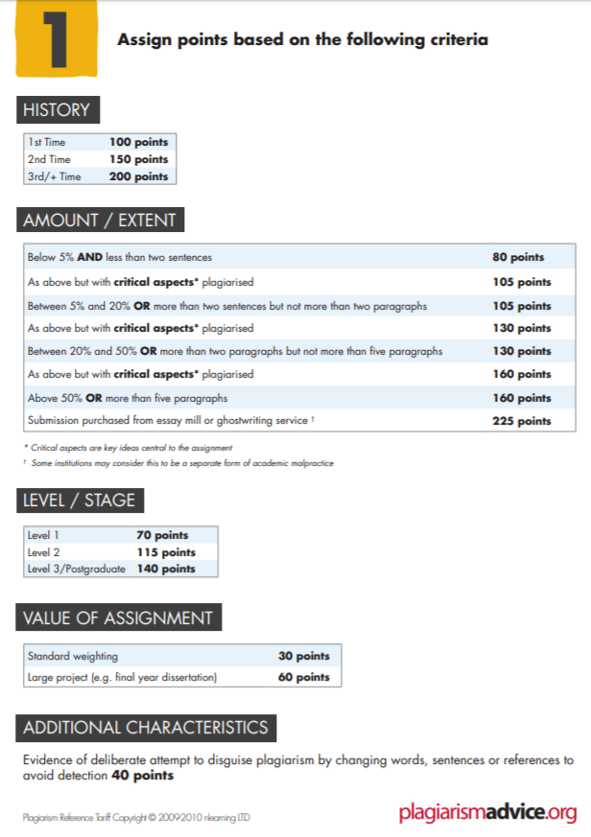

Appendix 3: Tariff amended for UCD use – Actions

Level | Points | Work submitted for gradable assessment
All | n/a | In all cases where it is determined that plagiarism has taken place a formal verbal or written warning is given, and a record is made contributing to the student’s previous history on the UCD Plagiarism Record System. In addition, the committee may apply any of the following penalties as appropriate:
School | 280-329 | Assessment component provisionally awarded NM - resubmission permitted, with a late submission grade penalty*
School | 330-379 | Assessment component provisionally awarded NM - resubmission permitted, with a late submission grade penalty*, or  Assessment component provisionally awarded NM – resubmission permitted but grade for the resubmitted assessment further capped or reduced
School | 380-479 | Assessment component provisionally awarded NM – resubmission permitted but grade for the resubmitted assessment further capped or reduced, or  Assessment component provisionally awarded NM – no opportunity to resubmit
Discipline* | 480-524 | Assessment component provisionally awarded NM – no opportunity to resubmit, or  Module provisionally awarded NM – module remediation required, but grade capped or reduced, or  Module awarded NM – no opportunity to remediate, or  Written reprimand, or  Fine not exceeding €1,000.
Discipline* | 525+ | Module provisionally awarded NM – module remediation permitted, but grade capped or reduced, or  Module awarded NM – no opportunity to remediate module  Written reprimand  Fine not exceeding €1,000  Exclusion from sittings of examinations for a specified period  Deprivation of any academic award  Suspension from the University for a stated period  Expulsion from the University

Level | Points | Work submitted for Pass/Resubmit/Fail assessments, including Stage Transfer Assessments and Research Degree Dissertations
All | n/a | In all cases where it is determined that plagiarism has taken place a formal verbal or written warning is given, and a record is made contributing to the student’s previous history on the UCD Plagiarism Record System. In addition, the committee may apply any of the following penalties as appropriate:
School | 280-479 | Revise, repeat or resubmission of the assessment permitted
Discipline* | 479+ | An appropriate penalty is taken from within the Discipline range of penalties
* Student Discipline Committees may decide to impose any of the penalties available to them under the Student Discipline Procedure separately or in combination as appropriate to the nature of the breach of the Student Code of Conduct.

Appendix 4: Process Map for School Investigation Procedure

Student Plagiarism Policy 2020 | Start / end
Process Map for School Investigation Procedure | Process
Academic integrity is an essential value of the University as it underpins all academic activities.  Suspected instances of student plagiarism in a module assessment should be reviewed within the School(s)* and a determination made as to | Referral
whether the matter may be addressed at School(s) level or whether a referral to the University Discipline Procedure is required.
* For the purpose of this policy, any academic unit offering modules is referred to as a School | Outcome / decision
Before submission of assessments students receive advice and guidance on correct citation and referencing, on avoiding plagiarism, and on the potential consequences of plagiarism being identified in assessed work.

An Examiner or Module Coordinator suspects plagiarism in a student’s assessment If the Examiner is not the Module Coordinator s/he consults the Module Coordinator

The Module Coordinator provides, or arranges that the student receives, advice about correct citation and / or refers the student to the UCD supports* for advice and guidance on good writing practices and plagiarism avoidance
Plagiarism is alleged. The Module Coordinator informs the student that their assessment is under scrutiny as an alleged case of plagiarism.
The Module Coordinator initiates the plagiarism procedure ± direct discussion of the case with the student ± consultation with the School Plagiarism Adviser (if appointed).

Poor academic practice is determined

The Module Coordinator refers the case to the School Plagiarism Committee, with a short report outlining the grounds of suspicion, a copy of the piece of work and any supporting evidence

The School Plagiarism Committee evaluates the case and decides whether plagiarism has taken place or not

The student is informed, by the Module Coordinator, through their UCD email address,
a) that their assessment is under scrutiny as an alleged instance of plagiarism by the School Plagiarism Committee, and b) of sources of support, such as those provided by the Student Advisers and/or the Students’ Union

If there was a previous breach, a judgement is made on whether to handle recurrence at School level or whether it should be referred to discipline.

Decision: Plagiarism has not occurred.
The assessment component grade stands. No record is

The student is invited to meet the School Plagiarism Committee to discuss the allegation
If the student does not respond or attend, following reasonable efforts to accommodate the student , the meeting will proceed in their absence
New
evidence
made on the Plagiarism Record System

Decision: plagiarism has taken place

Extenuating or mitigating circumstances may be considered after the decision has been made
Direct referral (without decision) to Discipline; e.g. serious first instance, or second or subsequent incidence, of plagiarism, or significant plagiarism in heavily weighted assignments.

The student receives a verbal or written warning, is directed on how to receive advice about academic integrity, and a record of the case is made in the Plagiarism Record System.  In addition the committee may:  - permit the student to re-submit the assessment component, a) incurring a late submission grade penalty, or b) direct that the grade be further capped or reduced**, or  - c) direct that the grade be further capped or reduced** without the opportunity to resubmit the assessment.  **the committee will be guided by a University-approved Tariff |  | The School Plagiarism Committee  - refers the alleged instance, without decision, for resolution under the University Student Discipline Procedure.  - prepares and sends a short report  - informs the student of referral  - advises the student of the supports available to them The facts and outcome of the case are recorded and a case summary added to the Plagiarism Record System.

The student and Module Coordinator are informed of the outcome (the decision ± penalty) by the School Plagiarism Committee. The outcome of the case is recorded on the Plagiarism Record System

The student can appeal an outcome (decision and/or penalty) of the School Plagiarism Committee to the University Student Appeal Procedure

